VISUALIZATION 1 (Excel)
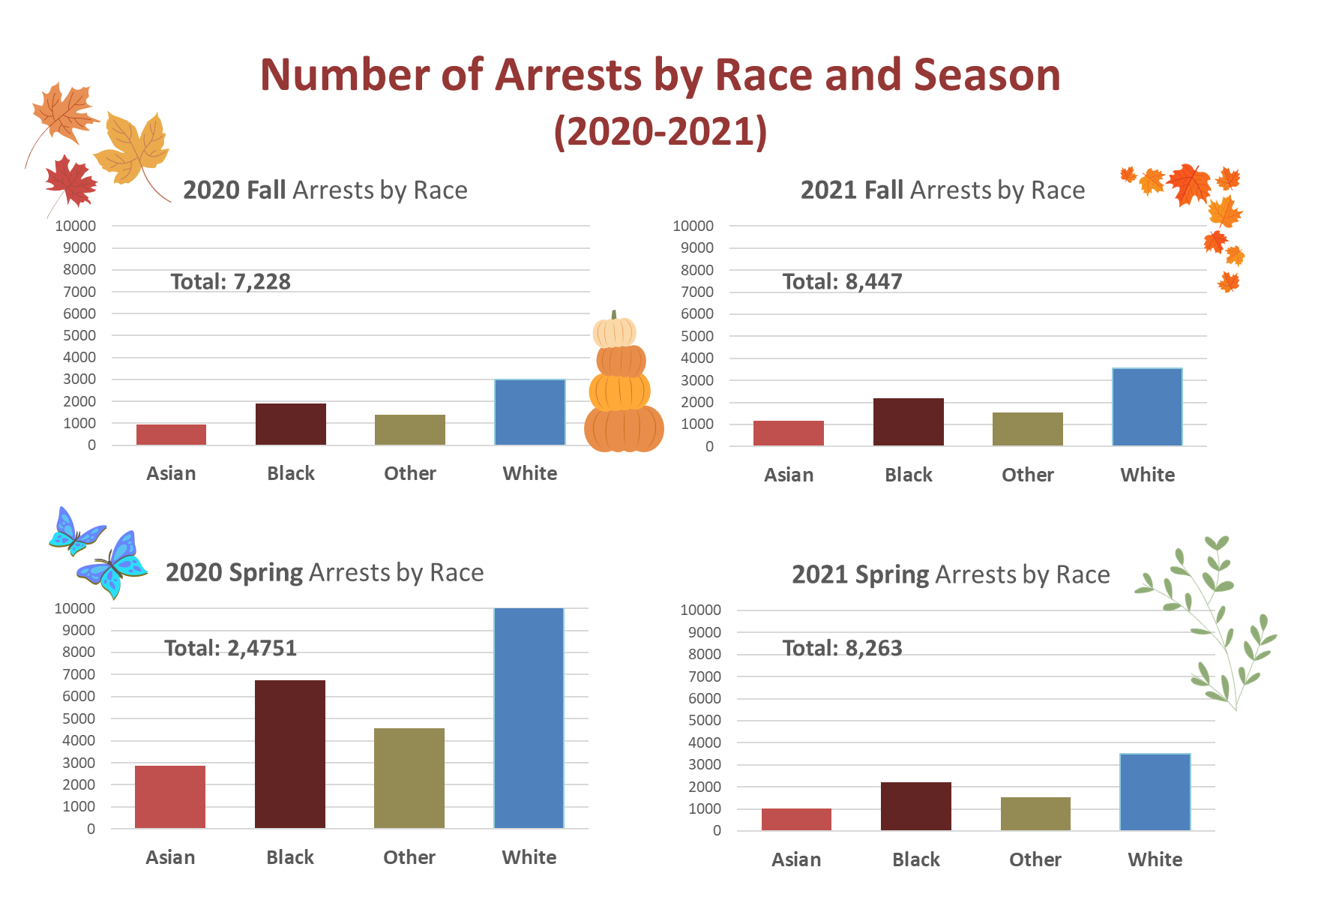
VISUALIZATION 2 (Python)
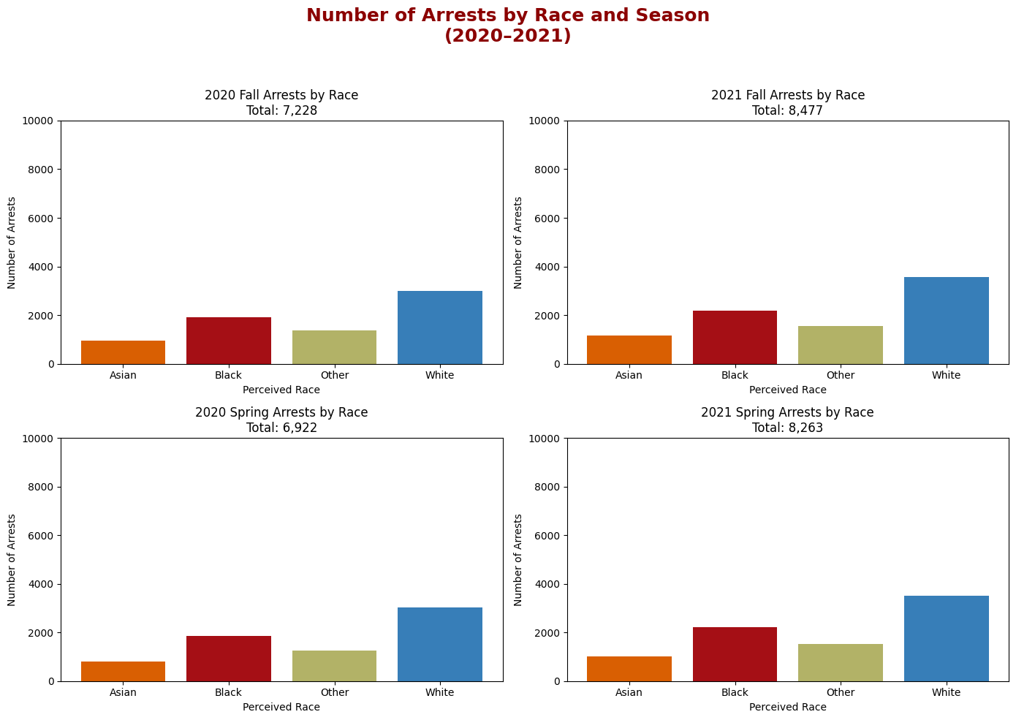
- What software did you use to create your data visualization?

Visualization 1: Excel (for creating pivot plots and the actual subplots) and powerpoint for inserting pictures.

Visualization 2: Python.

- Who is your intended audience?

Anyone who is interested in the number of arrests from year 2020-2021 and how the number may differ across the perceived racial category of arrested persons and across season (spring vs. summer).

- What information or message are you trying to convey with your visualization?

The total number of arrests between year 2020-2021 and how the number may differ between racial categories and season (spring vs. summer).

- What aspects of design did you consider when making your visualization? How did you apply them? With what elements of your plots?

Using visual cues (pictures/icons of spring and summer) to indicate season. Bolding of text to emphasize variation in year/season. Color codings of racial categories (i.e., different bars in each subplot).

- How did you ensure that your data visualizations are reproducible? If the tool you used to make your data visualization is not reproducible, how will this impact your data visualization?

Excel makes it hard to reproduce this plot. This makes it hard to replicate my plot using the exact same data or makes it difficult for others to check/modify my work.
Python makes it much easier to regenerate and modify the plot when the code and data are shared with others.

- How did you ensure that your data visualization is accessible?

I have uploaded my plot to a color-blind friendliness testing website (https://bioapps.byu.edu/colorblind_image_tester) where the colors still seem generally distinguishable for color-blind audiences:
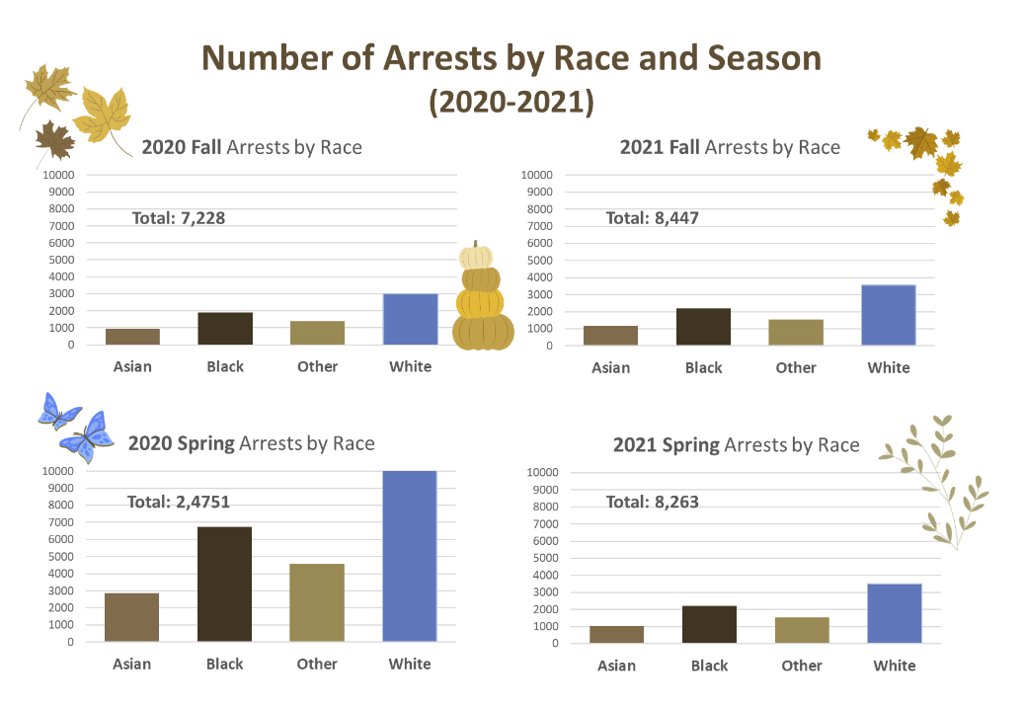

- Who are the individuals and communities who might be impacted by your visualization?

Likely racialized populations who have been historically overrepresented in police arrest. Perhaps also those who have experienced policing or who have been arrested in the past. Potentially community advocacy groups, policymakers, or researchers focused on racial justice and public safety. More broadly, Toronto residents who live in neighborhoods with higher arrest rates.

- How did you choose which features of your chosen dataset to include or exclude from your visualization?

The dataset also has age and location information associated with each arrested case. However, it may be overwhelming to the audience to digest all of those info all at once. Specifically, there is also number of cases (total and by racial categories) for the winter and fall seasons, but only for 2021. For comparisons across years (2020 vs. 2021), I decided to only focus on spring vs. fall comparisons.

- What ‘underwater labour’ contributed to your final data visualization product?

I cleaned/recoded the racial categories (e.g., merging East Asian and South Asian into one bigger category to simplify the plot). The people who prepared the data may have learned/defined what counts as an arrest case, how to represent these potentially sensitive data and hiding identifiable information.
Data citation: https://open.toronto.ca/dataset/police-race-and-identity-based-data-collection-arrests-strip-searches/

